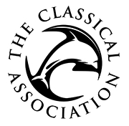

School Grant Application Form
Please attach as a Word document and send to canews@classicalassociation.org

Type of event (school trip, workshop, competition etc.):

Date of event (applications should be submitted at least three months in advance):

Name and address of school/college:

Name, position and email address of applicant:

School Year(s) and number of students participating:

How much are you applying for?
Please provide an estimated budget for the event indicating how the grant would be used and indicating any other sources of income:

Please provide further details about the proposed event below, continuing on a separate sheet if necessary (maximum one side of A4). Please read the guidelines on the CA website and ensure that you have addressed them to avoid any unnecessary delays to your application: https://classicalassociation.org/schools/

Please provide information about the demographic of your school/college, including percentage of pupils in receipt of free school meals or Pupil Premium, and those on the SEN register:

Please let us know how you heard about the CA grants scheme (if via a website or social media platform, please specify):

Payment: If your application is successful, the grant will be paid by BACS and you will be asked to provide details of an institutional account for the transfer to be made. Please note that the CA is unable to make grant payments to individuals.

