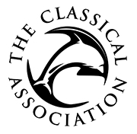

Major Grant Application Form
Please attach as a Word document and send to canews@classicalassociation.org
See https://classicalassociation.org/grants/ for further information.

Type of event/project:

Date of event/start of project (applications should be submitted for the 1 March or 1 September deadline):

Name and address of organisation/institution:

Name, position and email address of applicant:

How much are you applying for?

Please provide in a separate Word document (maximum two sides of A4) further details about the proposed event/project. A detailed budget breakdown should also be included, indicating how the grant would be used and any other sources of income. Please read the guidelines on the CA website and ensure that you have addressed them to avoid any unnecessary delays to your application: https://classicalassociation.org/grants/

Please let us know how you heard about the CA grants scheme (if via a website or social media platform, please specify):

Payment: If your application is successful, the grant will be paid by BACS and you will be asked to provide details of an institutional account for the transfer to be made. Please note that the CA is unable to make grant payments to individuals.

