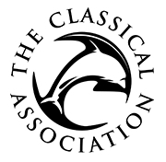

SUMMER SCHOOLS: Grant Application Form

The Classical Association awards grants to summer schools in the form of bursaries to allow students to attend the school. This form should be completed by summer school coordinators only and not by individuals attending the school. Please submit the completed form to canews@classicalassociation.org.

Name and dates of the summer school (applications should be submitted for a deadline at least three months in advance):

Summer school website details (where applicable):

Name and email address of coordinator:

Cost of attendance per individual:

Amount of each bursary:

How many bursaries would you like to apply for?

Please outline your selection criteria for bursaries

Please let us know how you heard about the CA grants scheme (if via a website or social media platform, please specify):

Payment: If your application is successful, the grant will be paid by BACS and you will be asked to provide details of an institutional account for the transfer to be made. Please note that the CA is unable to make grant payments to individuals.

